Java Enums

The **Enum in Java** is a data type which contains a fixed set of constants.

It can be used for days of the week (SUNDAY, MONDAY, TUESDAY, WEDNESDAY, THURSDAY, FRIDAY, and SATURDAY) , directions (NORTH, SOUTH, EAST, and WEST), season (SPRING, SUMMER, WINTER, and AUTUMN or FALL), colors (RED, YELLOW, BLUE, GREEN, WHITE, and BLACK) etc. According to the Java naming conventions, we should have all constants in capital letters. So, we have enum constants in capital letters.

Java Enums can be thought of as classes which have a fixed set of constants (a variable that does not change). The Java enum constants are static and final implicitly. It is available since JDK 1.5.

Enums are used to create our own data type like classes. The **enum** data type (also known as Enumerated Data Type) is used to define an enum in Java. Unlike C/C++, enum in Java is more *powerful*. Here, we can define an enum either inside the class or outside the class.

Java Enum internally inherits the *Enum class*, so it cannot inherit any other class, but it can implement many interfaces. We can have fields, constructors, methods, and main methods in Java enum.

Points to remember for Java Enum

* Enum improves type safety
* Enum can be easily used in switch
* Enum can be traversed
* Enum can have fields, constructors and methods
* Enum may implement many interfaces but cannot extend any class because it internally extends Enum class

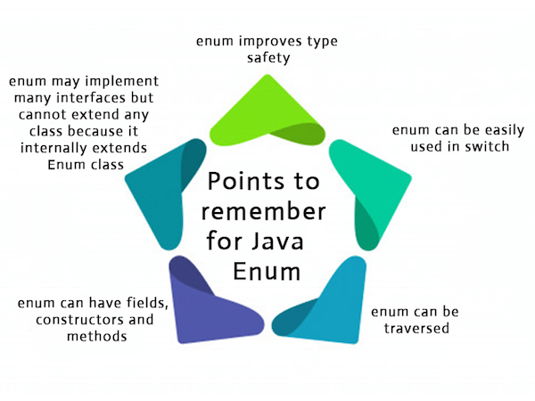

Simple Example of Java Enum

1. **class** EnumExample1{
2. //defining the enum inside the class
3. **public** **enum** Season { WINTER, SPRING, SUMMER, FALL }
4. //main method
5. **public** **static** **void** main(String[] args) {
6. //traversing the enum
7. **for** (Season s : Season.values())
8. System.out.println(s);
9. }}

[**Test it Now**](https://www.javatpoint.com/opr/test.jsp?filename=EnumExample1)

Output:

WINTER

SPRING

SUMMER

FALL

Let us see another example of Java enum where we are using value(), valueOf(), and ordinal() methods of Java enum.

1. **class** EnumExample1{
2. //defining enum within class
3. **public** **enum** Season { WINTER, SPRING, SUMMER, FALL }
4. //creating the main method
5. **public** **static** **void** main(String[] args) {
6. //printing all enum
7. **for** (Season s : Season.values()){
8. System.out.println(s);
9. }
10. System.out.println("Value of WINTER is: "+Season.valueOf("WINTER"));
11. System.out.println("Index of WINTER is: "+Season.valueOf("WINTER").ordinal());
12. System.out.println("Index of SUMMER is: "+Season.valueOf("SUMMER").ordinal());
14. }}

Output:

WINTER

SPRING

SUMMER

FALL

Value of WINTER is: WINTER

Index of WINTER is: 0

Index of SUMMER is: 2

Note: Java compiler internally adds values(), valueOf() and ordinal() methods within the enum at compile time. It internally creates a static and final class for the enum.

What is the purpose of the values() method in the enum?

The Java compiler internally adds the values() method when it creates an enum. The values() method returns an array containing all the values of the enum.

What is the purpose of the valueOf() method in the enum?

The Java compiler internally adds the valueOf() method when it creates an enum. The valueOf() method returns the value of given constant enum.

What is the purpose of the ordinal() method in the enum?

The Java compiler internally adds the ordinal() method when it creates an enum. The ordinal() method returns the index of the enum value.

Defining Java Enum

The enum can be defined within or outside the class because it is similar to a class. The semicolon (;) at the end of the enum constants are optional. For example:

1. **enum** Season { WINTER, SPRING, SUMMER, FALL }

Or,

1. **enum** Season { WINTER, SPRING, SUMMER, FALL; }

Both the definitions of Java enum are the same.

Java Enum Example: Defined outside class

1. **enum** Season { WINTER, SPRING, SUMMER, FALL }
2. **class** EnumExample2{
3. **public** **static** **void** main(String[] args) {
4. Season s=Season.WINTER;
5. System.out.println(s);
6. }}

[**Test it Now**](https://www.javatpoint.com/opr/test.jsp?filename=EnumExample2)

Output:

WINTER

Java Enum Example: Defined inside class

1. **class** EnumExample3{
2. **enum** Season { WINTER, SPRING, SUMMER, FALL; }//semicolon(;) is optional here
3. **public** **static** **void** main(String[] args) {
4. Season s=Season.WINTER;//enum type is required to access WINTER
5. System.out.println(s);
6. }}

[**Test it Now**](https://www.javatpoint.com/opr/test.jsp?filename=EnumExample3)

Output:

WINTER

Java Enum Example: main method inside Enum

If you put main() method inside the enum, you can run the enum directly.

1. **enum** Season {
2. WINTER, SPRING, SUMMER, FALL;
3. **public** **static** **void** main(String[] args) {
4. Season s=Season.WINTER;
5. System.out.println(s);
6. }
7. }

WINTER

### Initializing specific values to the enum constants

The enum constants have an initial value which starts from 0, 1, 2, 3, and so on. But, we can initialize the specific value to the enum constants by defining fields and constructors. As specified earlier, Enum can have fields, constructors, and methods.

### Example of specifying initial value to the enum constants

1. **class** EnumExample4{
2. **enum** Season{
3. WINTER(5), SPRING(10), SUMMER(15), FALL(20);
5. **private** **int** value;
6. **private** Season(**int** value){
7. **this**.value=value;
8. }
9. }
10. **public** **static** **void** main(String args[]){
11. **for** (Season s : Season.values())
12. System.out.println(s+" "+s.value);
14. }}

[**Test it Now**](https://www.javatpoint.com/opr/test.jsp?filename=EnumExample4)

Output:

WINTER 5

SPRING 10

SUMMER 15

FALL 20

#### Constructor of enum type is private. If you don't declare private compiler internally creates private constructor.

1. **enum** Season{
2. WINTER(10),SUMMER(20);
3. **private** **int** value;
4. Season(**int** value){
5. **this**.value=value;
6. }
7. }

### Internal code generated by the compiler for the above example of enum type

1. **final** **class** Season **extends** Enum
2. {
3. **public** **static** Season[] values()
4. {
5. **return** (Season[])$VALUES.clone();
6. }
7. **public** **static** Season valueOf(String s)
8. {
9. **return** (Season)Enum.valueOf(Season, s);
10. }
11. **private** Season(String s, **int** i, **int** j)
12. {
13. **super**(s, i);
14. value = j;
15. }
16. **public** **static** **final** Season WINTER;
17. **public** **static** **final** Season SUMMER;
18. **private** **int** value;
19. **private** **static** **final** Season $VALUES[];
20. **static**
21. {
22. WINTER = **new** Season("WINTER", 0, 10);
23. SUMMER = **new** Season("SUMMER", 1, 20);
24. $VALUES = (**new** Season[] {
25. WINTER, SUMMER
26. });
27. }
28. }

### Can we create the instance of Enum by new keyword?

|  |
| --- |
| No, because it contains private constructors only. |

### Can we have an abstract method in the Enum?

Yes, Of course! we can have abstract methods and can provide the implementation of these methods.

## Java Enum in a switch statement

We can apply enum on switch statement as in the given example:

**Example of applying Enum on a switch statement**

1. **class** EnumExample5{
2. **enum** Day{ SUNDAY, MONDAY, TUESDAY, WEDNESDAY, THURSDAY, FRIDAY, SATURDAY}
3. **public** **static** **void** main(String args[]){
4. Day day=Day.MONDAY;
6. **switch**(day){
7. **case** SUNDAY:
8. System.out.println("sunday");
9. **break**;
10. **case** MONDAY:
11. System.out.println("monday");
12. **break**;
13. **default**:
14. System.out.println("other day");
15. }
16. }}

[**Test it Now**](https://www.javatpoint.com/opr/test.jsp?filename=EnumExample5)

Output:

monday